- Git flow branching strategy:
Release – is used for production environment
Develop- is used for Development/staging environment
Feature- is used for next updates.
Hotfix – is used to fix the bugs of production server.
Master/main – is used as a copy for Release branch.
- 3 Environment
- Development
- Staging/ Testing/UAT
- Production Environment.

Note for inter view important
Branching strategy
Git pull and git fetch
Git merge and git rebase
Git cherry-pick

- To check git branch use git branch –list
- Check status of local repo. Using git status command
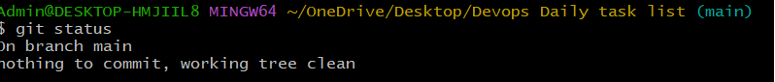
- How to create branch. Git branch name of newbranch. When you create new branch then all file of Main branch is copy by default on your new branch.
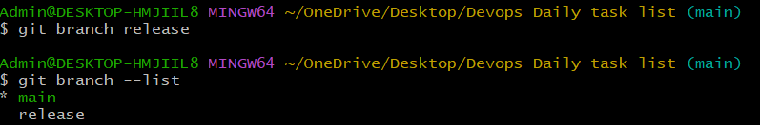
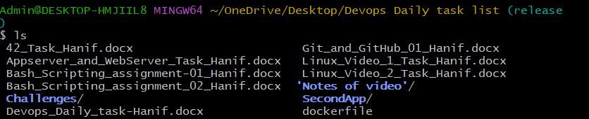
Above screen * present current branch.
- Now I want to switch my branch using git checkout branchname.
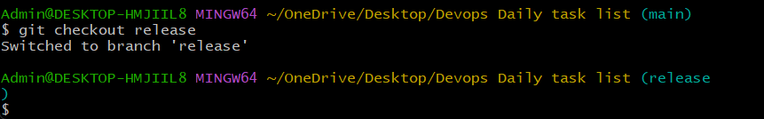
- Now I want to merge release branch data in to hotfix branch
- First got your base branch(means Destination branch)
- Note When you create any file in release branch then you should commit that changes other wise it will show in your other branch also(createdbymainbranch file is created in main branch that file also show in other branch because I not committed that changes)
- Ans is When you switch branches in Git without committing, your changes stay in the working directory, so they “follow you” to the next branch.
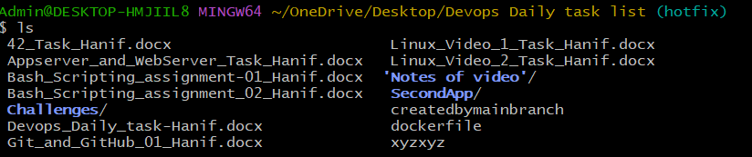
- Now I commit changes of release branch
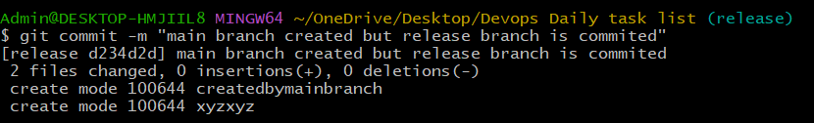
- Now I switch to hotfix branch and ls command use now I am not able to see release branch changes.
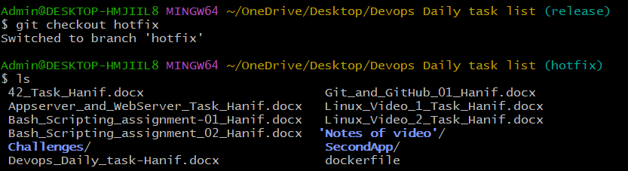
- Now run the command git merege source branch name
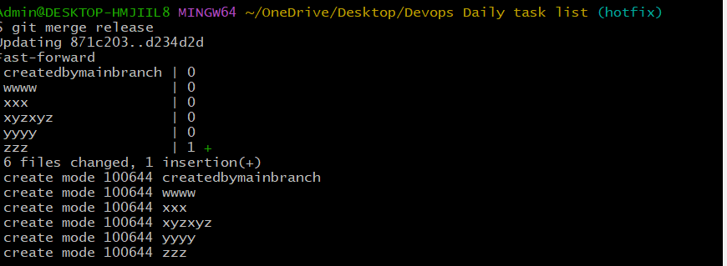
- Now file is merge in hotfix branch.
- How to merger a specific file in hotfix branch to main branch.
- There is no option to merge a specific file.
- We can merger a specific commit. If the commit has only one file then you can see that one file in branch. If commit has 10 file we merge all 10 file.
- First we need to no that commit id. Go to your hotfix branch Using git log
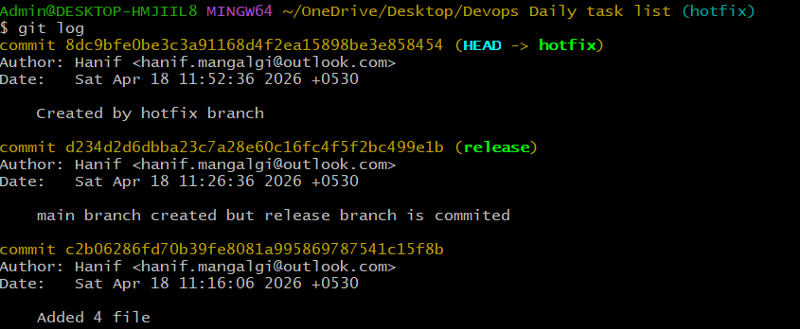
- Now copy the commit id and go to you main branch
- Use command git cherry-pick commitID
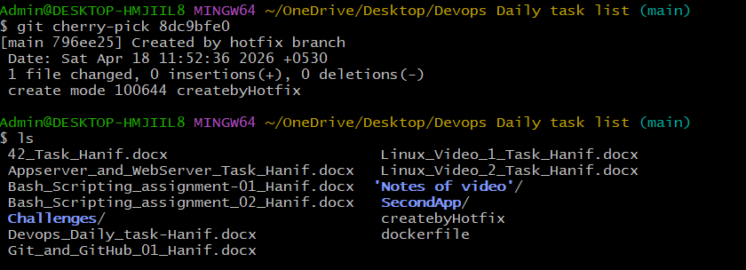
- Now you see createdbyhotfix show in main branch
- PR-Pull Request is used to merge 2 different branches. Pull Request work on only GUI level not on git.
- How to change commit message. Using git commit –amend it will vi editor to make changes as you want.
It open last committed.

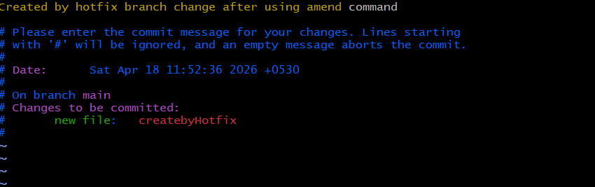
Now you see message is changed
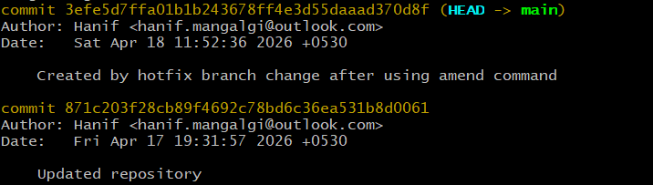

- If you want a tracking file should not be commit then you use git stash command all tracking file move to stashing area.
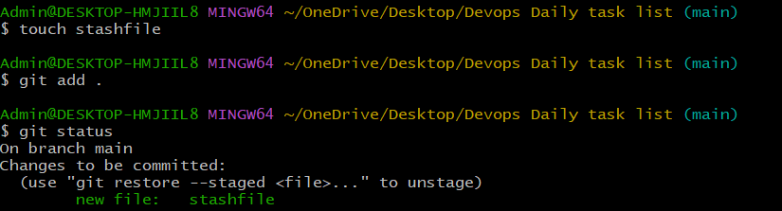
You see above stashfile is in tracking area file. Now I want to be commit that file to use git stash command
Now you see the file is move to stash memory
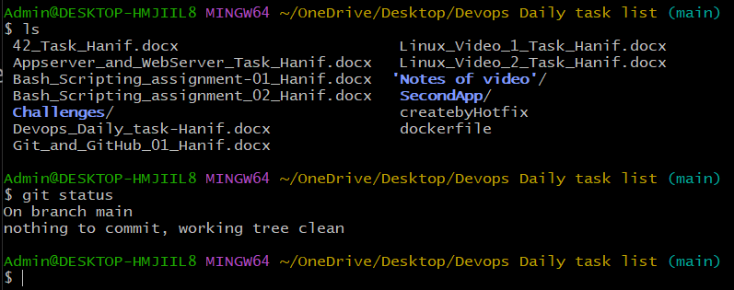
Now check stash memory file. Using command git stash list
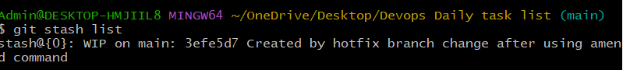
Now I want to back stash file. Using git stash pop
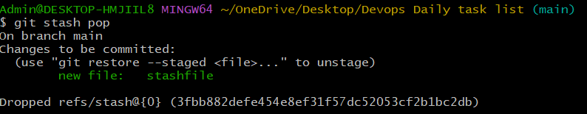
Now it show you stashfile is in tracking area.
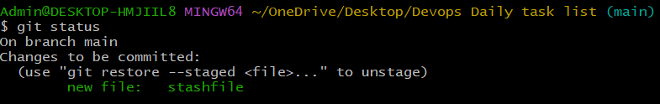

Note : 1) Branching Strategy 2) merge conflict 3) git pull and git fetch 4) git merge and git rebase

- What is merge conflict.
- when developers working on same file.
- When we have two identical files with similar content.
Solution we have hello.txt file in 2 branch Hotfix and release branch
This is a file of release branch name is hello and commit it
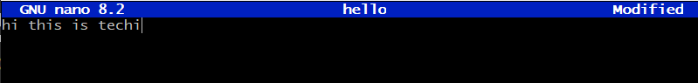
This is a file of hotfix branch name is hello and commit it
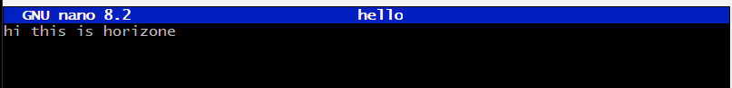
Now I am going to merge 2 branch of release and hotfix. It show message conflict.
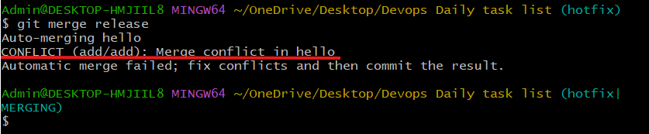
There is no such command to resolve this conflict. You do it manually.
- First check git status
- 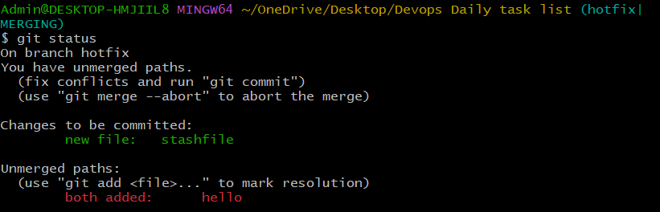
- Now open file using vi filename
- Now it show conflict code
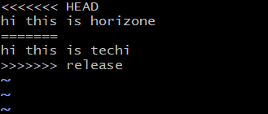
- Now you add manually what you want add in this file. And save file
- 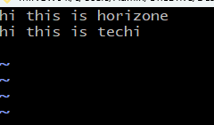
- After that use git add . & commit changes you don.
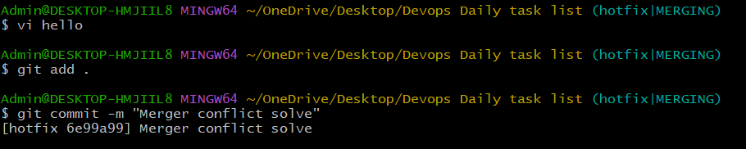
- Now see changes of hello file using cat command
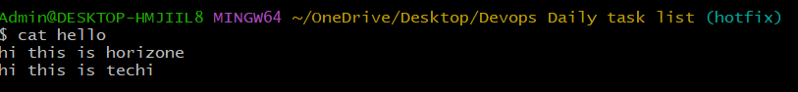
Note use git push -u origin Main---to push local repo data to Central repo
- Why to use .gitignore to ignore file where
- Create .gitignore file using vi command.
Now try to add which file you want to ignore.
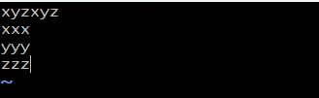
Now try add .gitignore file in tracking area and commit the changes.(we ignore using extension and folder also)
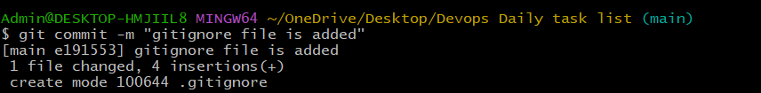
Now push changes to central repo.
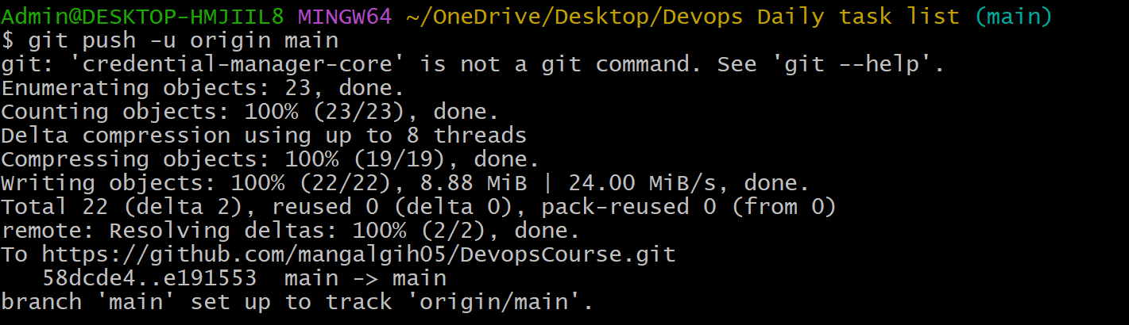
- To clone main branch from central repo to local repo
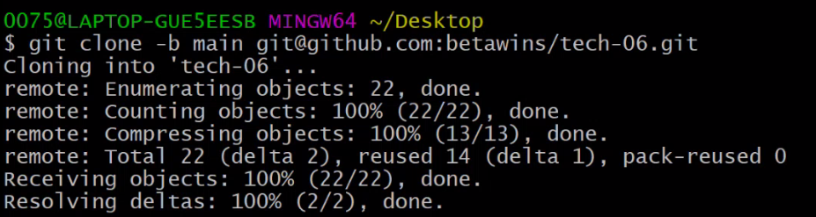
- What is the README file.
All the information of repository mention in readme file. He will get agenda and purpose of the repository.
- Git fetch command.
To download to collect configuration changes using fetch command.
- Merge 4 commit in to one commit. Use below command git rebase -I head~4 to make 4 commit into one commit.
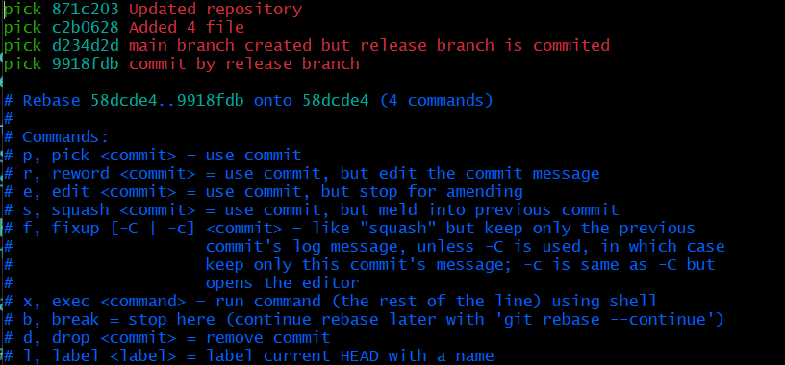
To change pick to squash above head image and save the file.
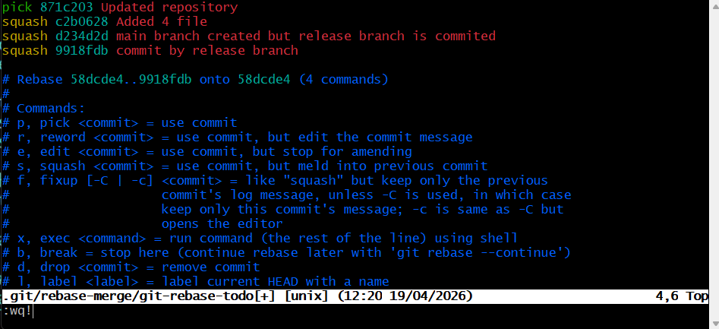
Now check using git log command
